**Capstone Diagrams**

**Product Perspective**

Our objective with this project is to automate the diagnosis of eye disease and provide appropriate suggestions to eye disease patients by training deep CNN model to grade the severities of eye disease fundus images. We have implemented the use of CNN and image processing to analyse the images and successfully detect the stage of eye disease that the patient is currently suffering from.

**Block Diagram**

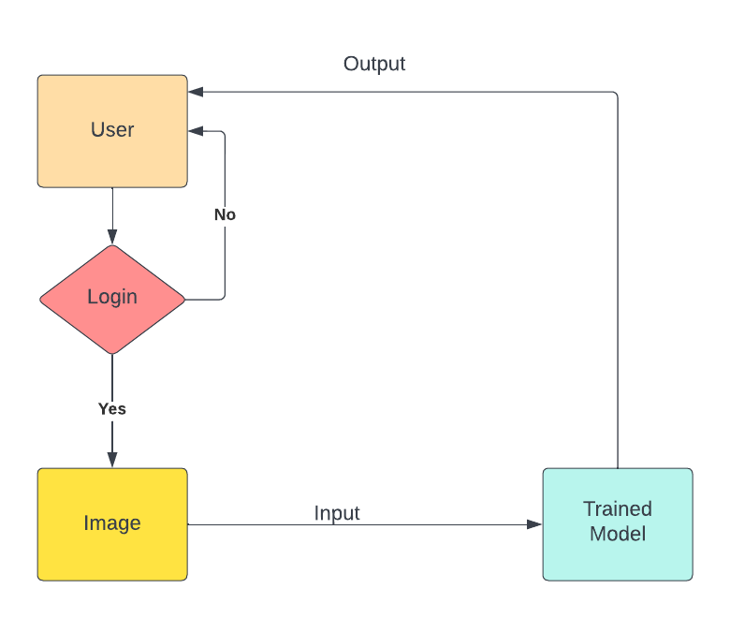

**Use Case Diagram**

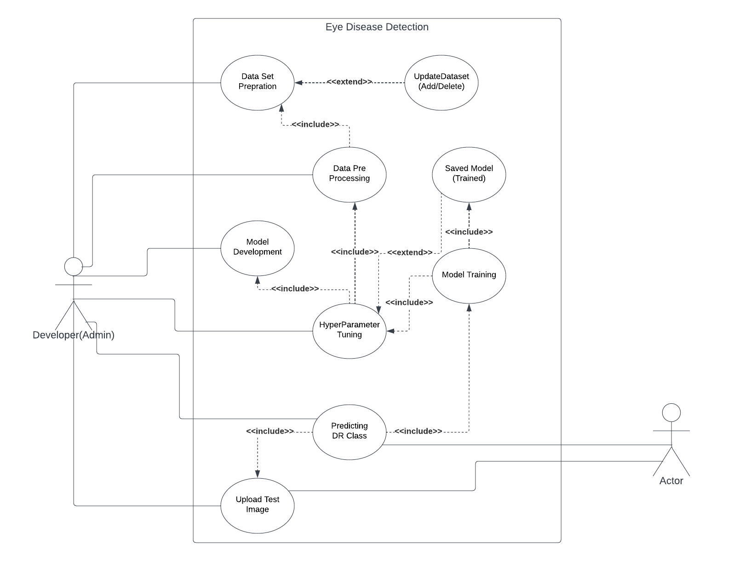

**List of tasks and sub-tasks**

**Data Preparation**

* Data collection
* Data preprocessing for reduction of image size and removing noise.
* Data augmentation to enlarge the training dataset and will improve performance of model.

**Model Deployment**

* Designing a deep learning model
* Model training
* Hyperparameter tuning for improving the accuracy of the model

**Creating Web App**

* Building web app.
* Creating secure login page.
* Creating readable web portal with upload image field.

**Swimlane Diagram**

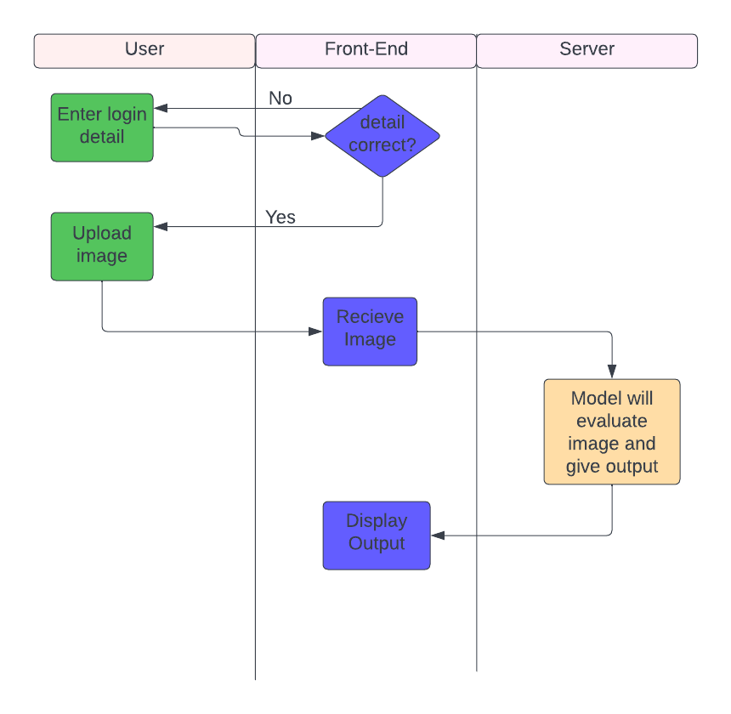

**Activity Diagram**

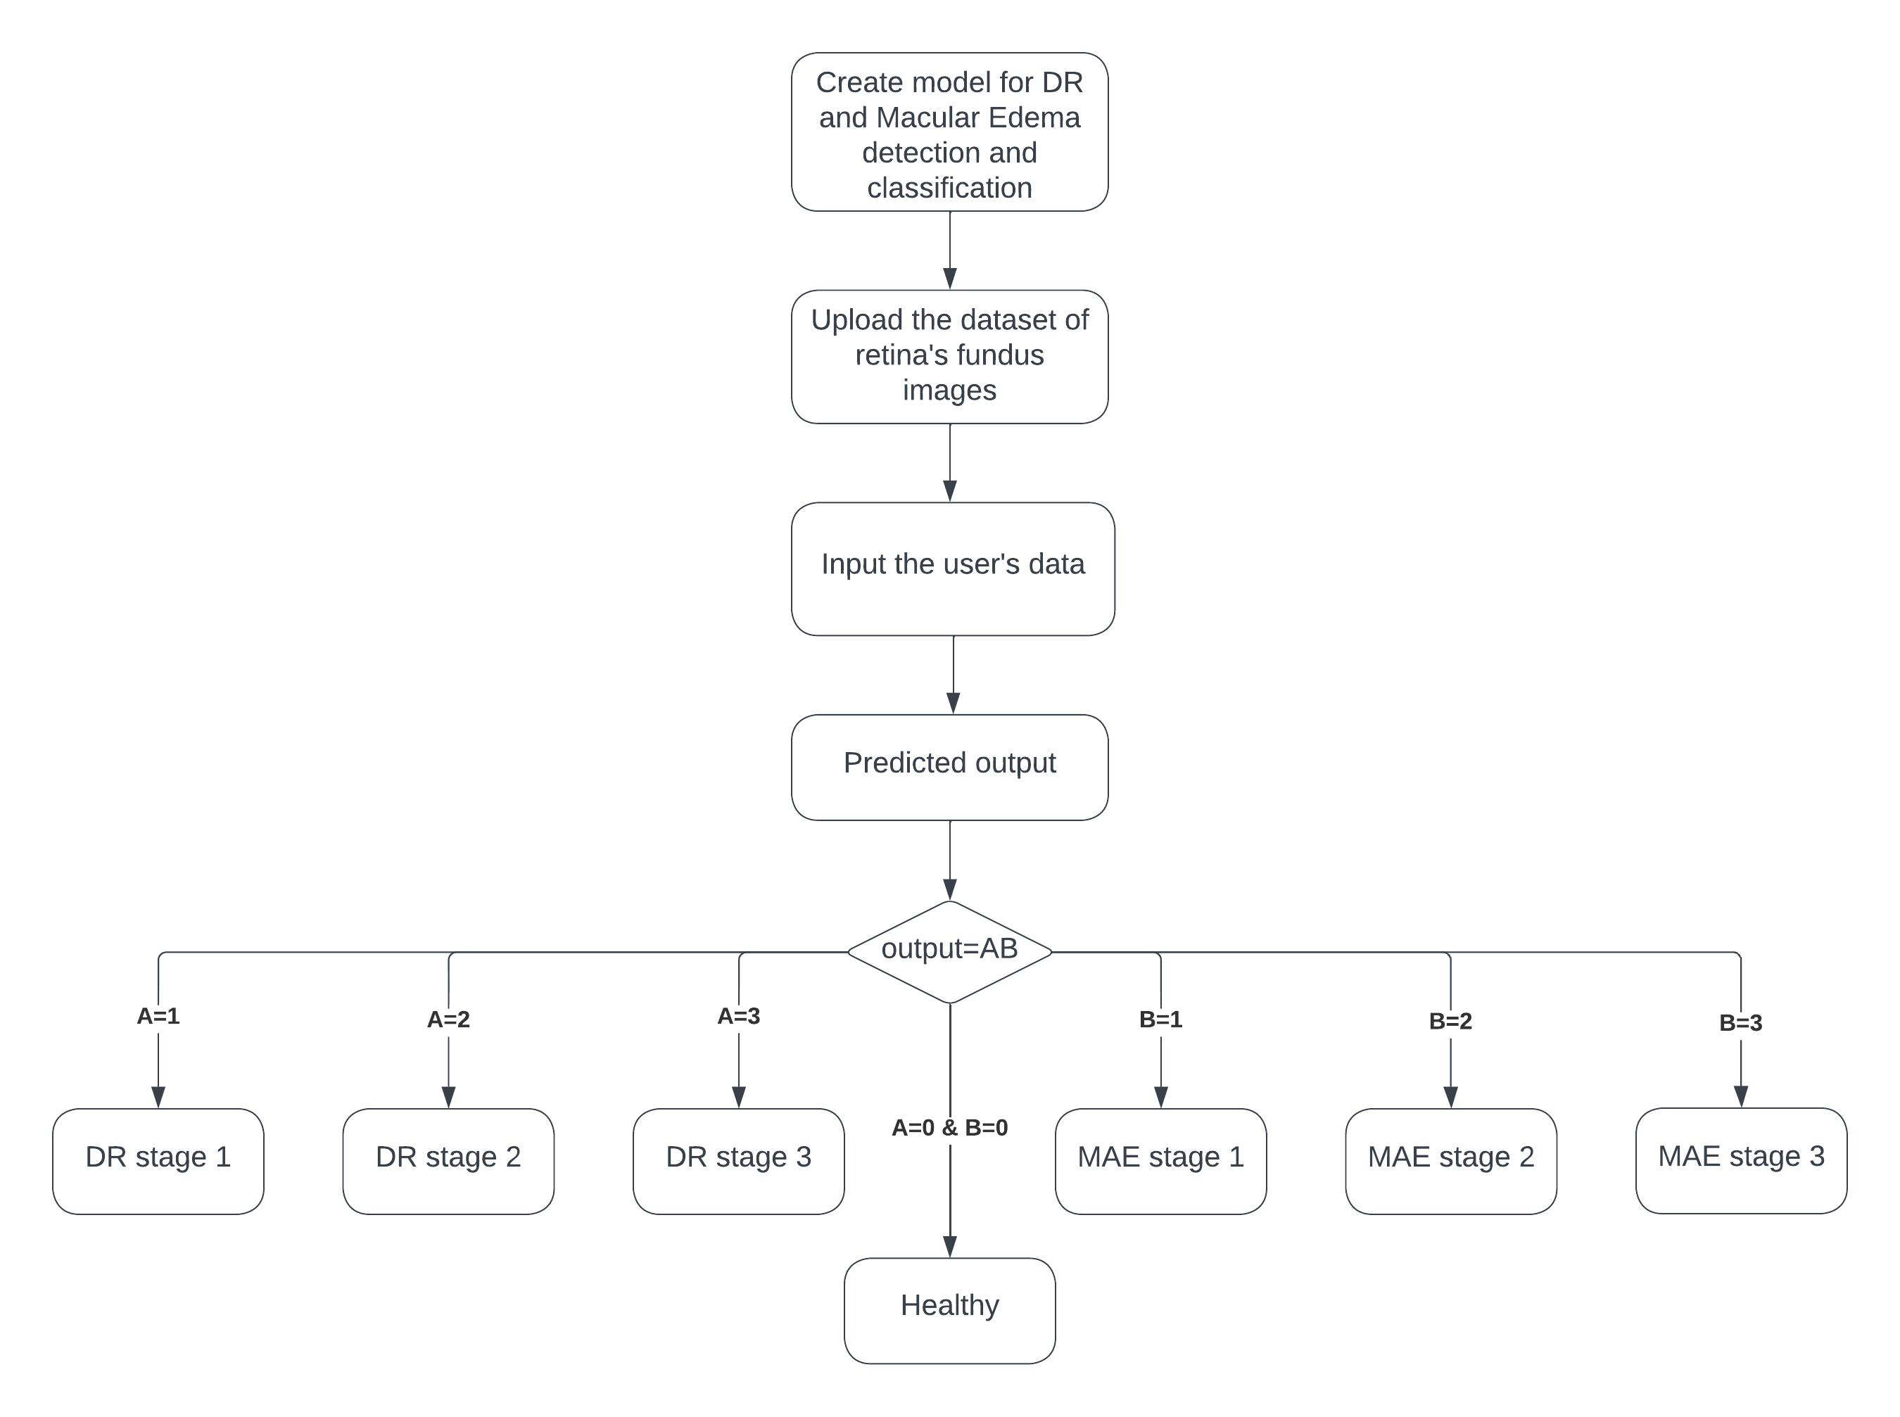

**Work Breakdown Structure**

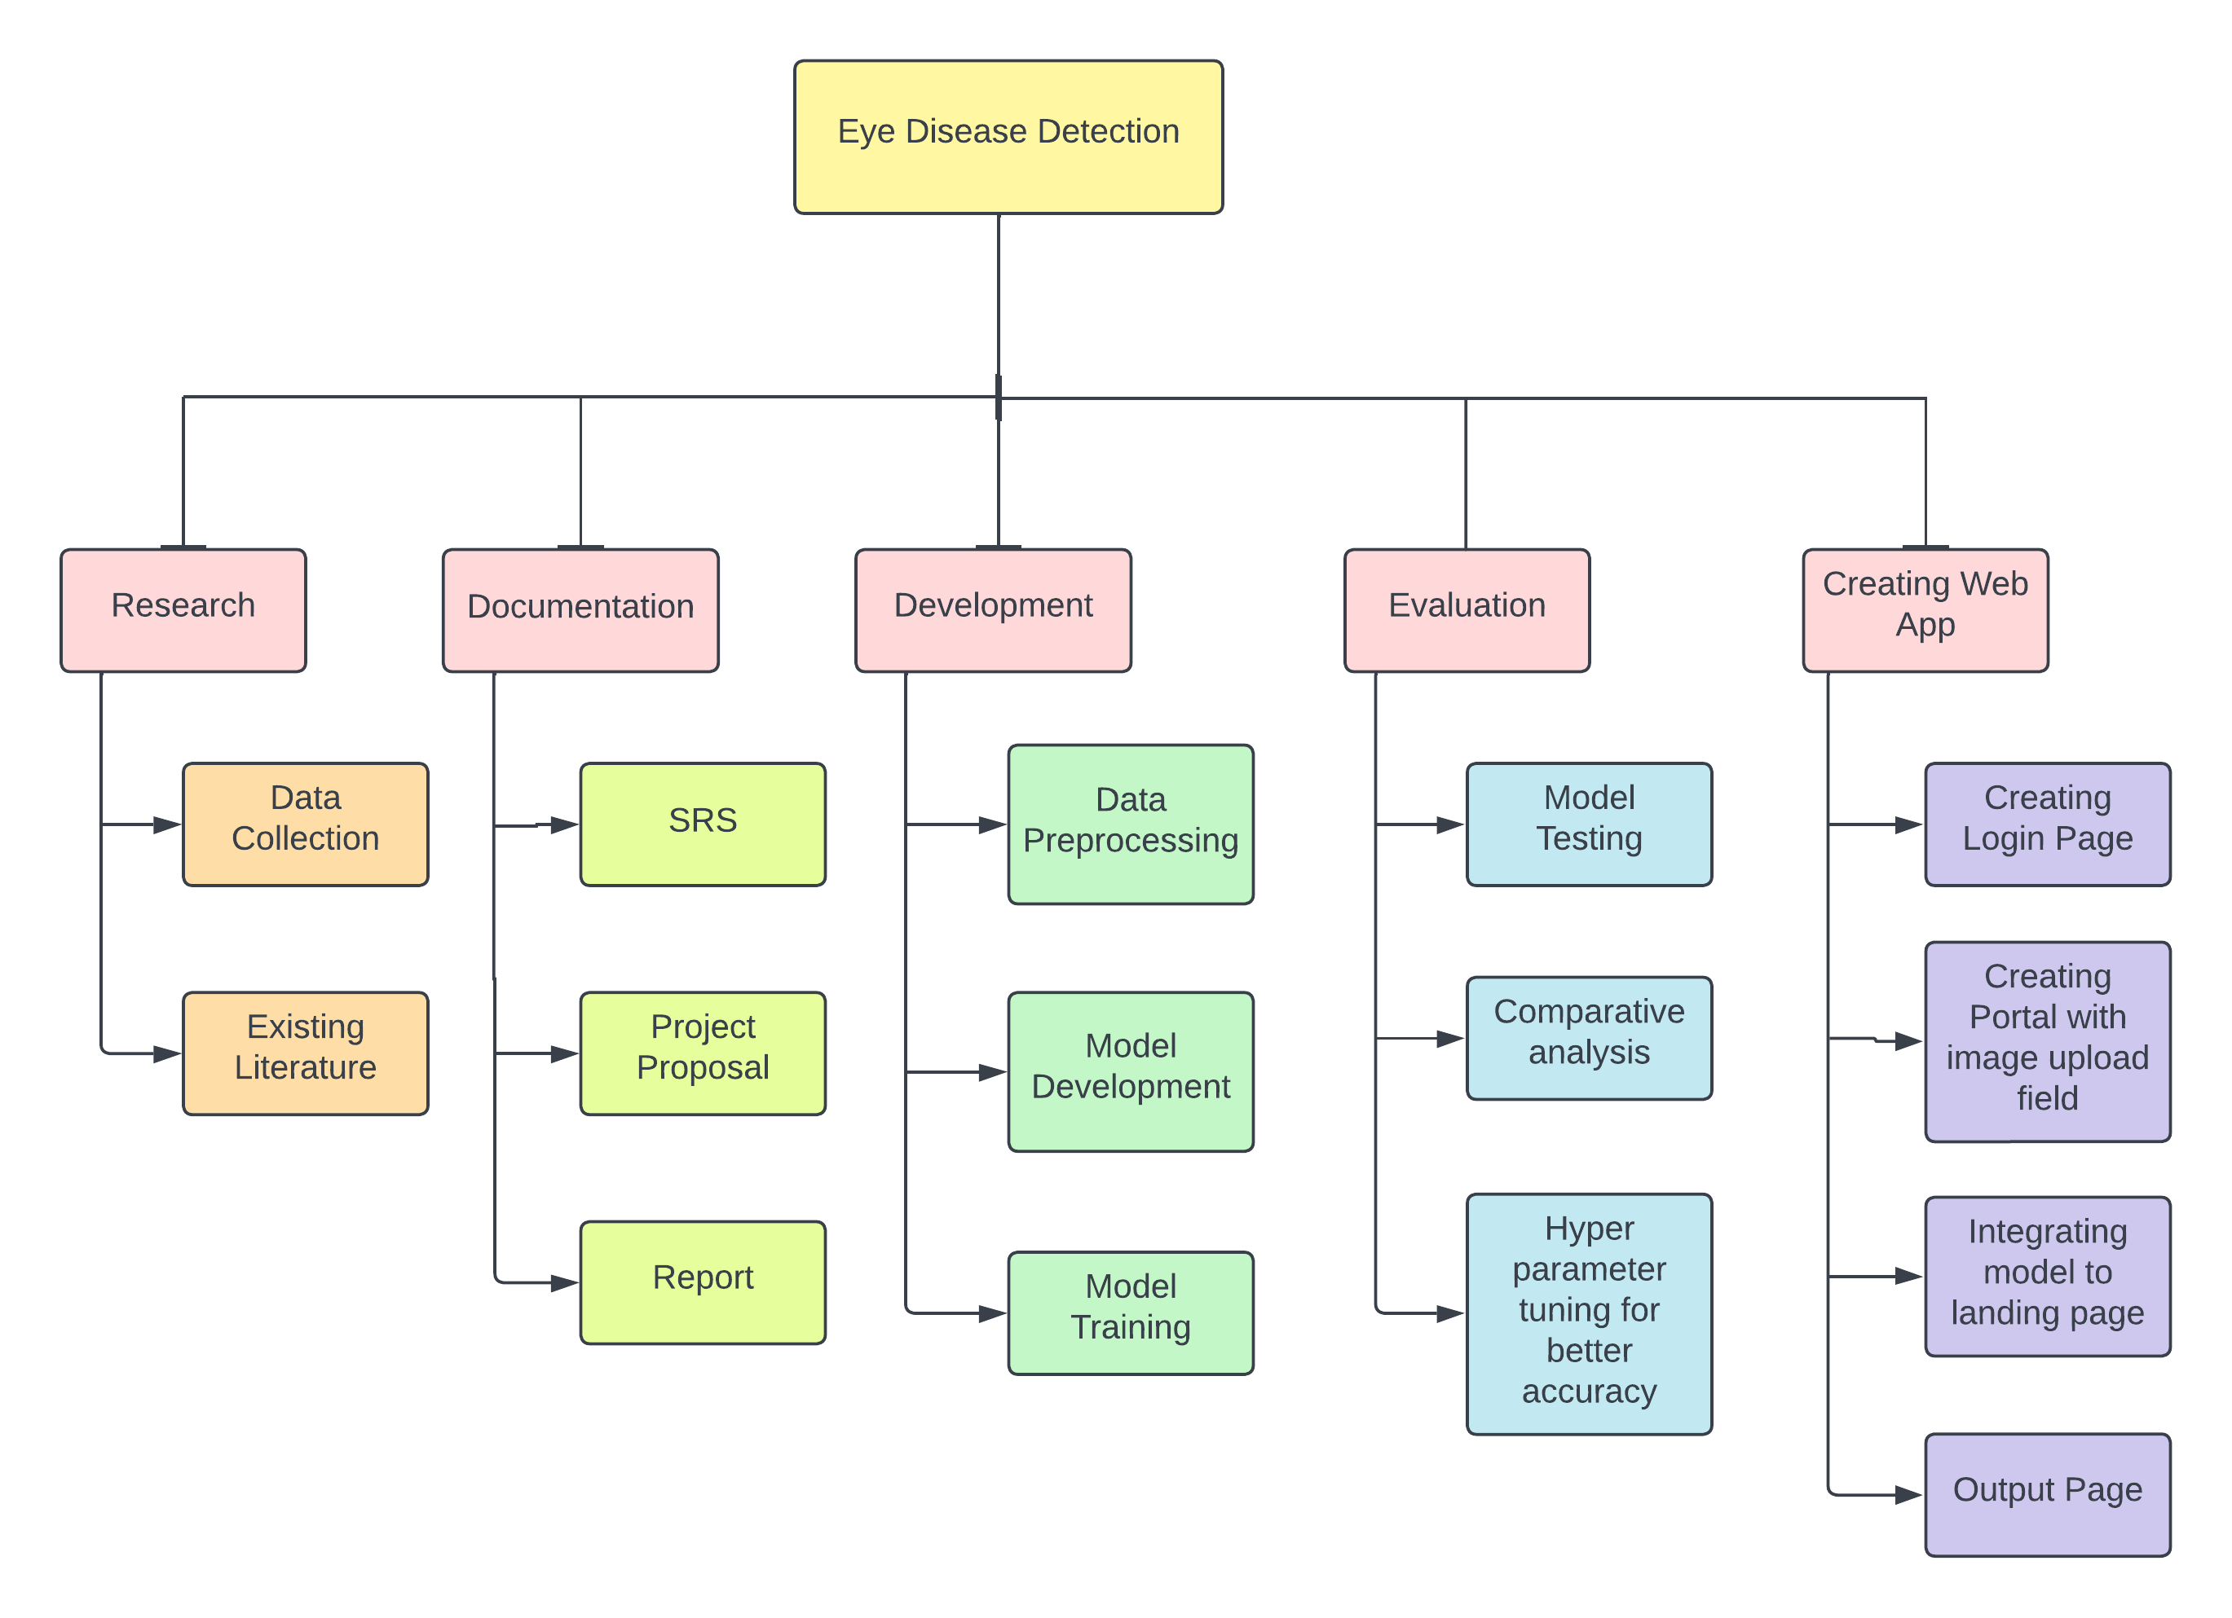

**Gantt Chart**

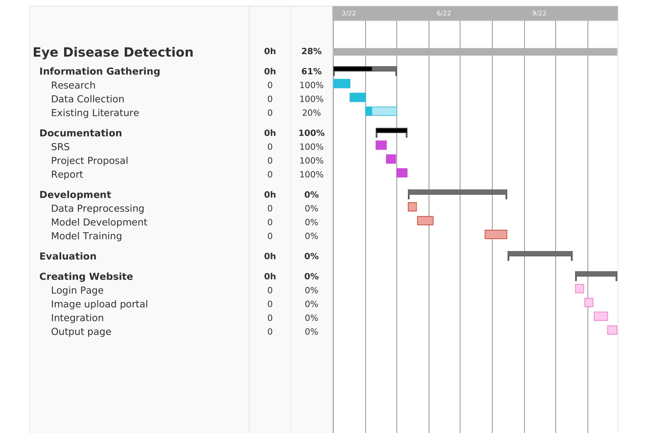

**Functional Requirements and Non- Functional Requirements**

**Functional Requirements**

* The model should be able to detect eye diseases successfully and classify the detected disease to different stages for proper treatment.
* System should be able to preprocess the image efficiently.
* System should be able to perform comparative analysis.
* System should be able to produce desired output with efficiency and accuracy.
* False negative rate of the model should be minimised.

**Non- Functional Requirements**

**Performance Requirements**

* ▪ The website should revert results swiftly.
* ▪ Image upload should not take hefty time.
* ▪ Website should be accessible with a moderate internet connection.

**safety Requirements**

* The CNN model should only be deployed when a consistent and satisfactory accuracy has been achieved.

**Security Requirements**

* The website should be protected with standard protocols and updates against phishing, spam or other hacking attacks.
* Only valid image formats should be accepted from user.